While the generalized model shows a negative relationship between age and expenditure, a closer inspection shows that when dividing the sample into 2 groups (<40 and >40 years) the relationship is actually positive, and with higher significance for the younger group (consistently expending more as they age) until they hit 40 years old, at which their expenditure drops and becomes less stable (As shown by the low t-statistic and high p-value over t.

One could predict better the expenditures of a younger population than an older one.

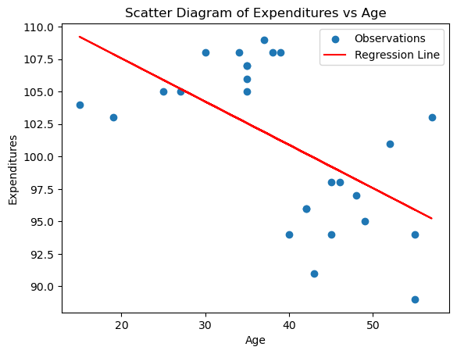

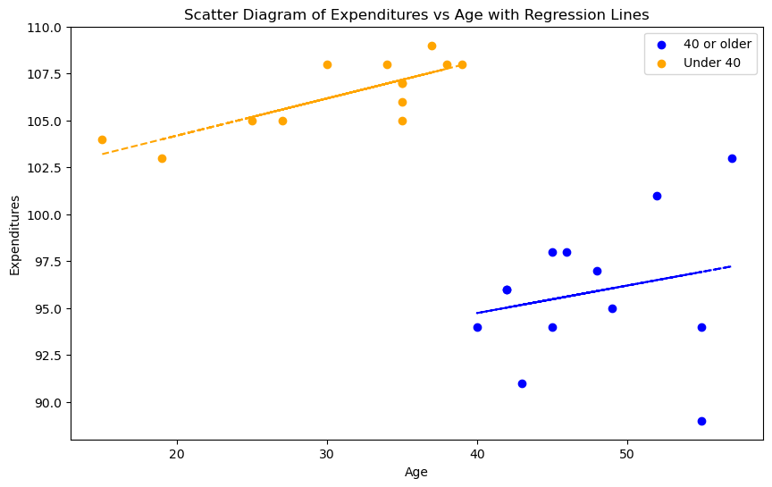

Alpha (intersect) Beta (Slope)

**Model for all clients:**

OLS Regression Results

==============================================================================

Dep. Variable: Expenditures R-squared: 0.338

Model: OLS Adj. R-squared: 0.310

Method: Least Squares F-statistic: 12.24

Date: Tue, 02 Jan 2024 Prob (F-statistic): 0.00185

Time: 12:22:52 Log-Likelihood: -78.076

No. Observations: 26 AIC: 160.2

Df Residuals: 24 BIC: 162.7

Df Model: 1

Covariance Type: nonrobust

==============================================================================

coef std err t P>|t| [0.025 0.975]

------------------------------------------------------------------------------

const 114.2411 3.882 29.428 0.000 106.229 122.253

Age -0.3336 0.095 -3.498 0.002 -0.530 -0.137

==============================================================================

Omnibus: 5.126 Durbin-Watson: 1.955

Prob(Omnibus): 0.077 Jarque-Bera (JB): 1.689

Skew: -0.021 Prob(JB): 0.430

Kurtosis: 1.752 Cond. No. 159.

==============================================================================

**Model for clients aged 40 or older:**

OLS Regression Results

==============================================================================

Dep. Variable: Expenditures R-squared: 0.048

Model: OLS Adj. R-squared: -0.039

Method: Least Squares F-statistic: 0.5507

Date: Tue, 02 Jan 2024 Prob (F-statistic): 0.474

Time: 12:08:05 Log-Likelihood: -34.827

No. Observations: 13 AIC: 73.65

Df Residuals: 11 BIC: 74.78

Df Model: 1

Covariance Type: nonrobust

==============================================================================

coef std err t P>|t| [0.025 0.975]

------------------------------------------------------------------------------

const 88.8719 9.458 9.396 0.000 68.054 109.690

Age 0.1465 0.197 0.742 0.474 -0.288 0.581

==============================================================================

Omnibus: 1.384 Durbin-Watson: 2.745

Prob(Omnibus): 0.501 Jarque-Bera (JB): 0.534

Skew: -0.496 Prob(JB): 0.766

Kurtosis: 2.957 Cond. No. 427.

==============================================================================

**Model for clients younger than 40:**

OLS Regression Results

==============================================================================

Dep. Variable: Expenditures R-squared: 0.644

Model: OLS Adj. R-squared: 0.612

Method: Least Squares F-statistic: 19.90

Date: Tue, 02 Jan 2024 Prob (F-statistic): 0.000962

Time: 12:08:05 Log-Likelihood: -19.212

No. Observations: 13 AIC: 42.42

Df Residuals: 11 BIC: 43.55

Df Model: 1

Covariance Type: nonrobust

==============================================================================

coef std err t P>|t| [0.025 0.975]

------------------------------------------------------------------------------

const 100.2323 1.416 70.791 0.000 97.116 103.349

Age 0.1980 0.044 4.460 0.001 0.100 0.296

==============================================================================

Omnibus: 0.100 Durbin-Watson: 1.864

Prob(Omnibus): 0.951 Jarque-Bera (JB): 0.154

Skew: -0.135 Prob(JB): 0.926

Kurtosis: 2.541 Cond. No. 141.

==============================================================================